晋江市伟冠双语实验学校

三年级U6 My sweet home校本作业

Must to do（必做）

一．Look and match.

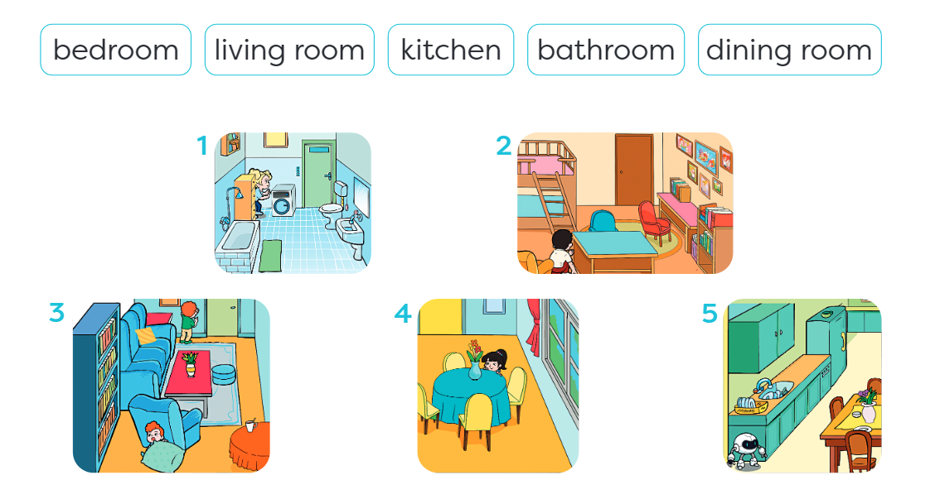

二．Read and trace.

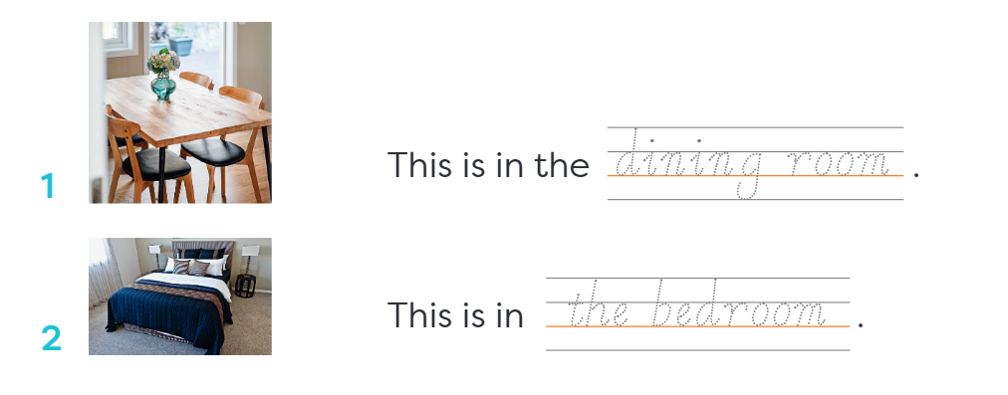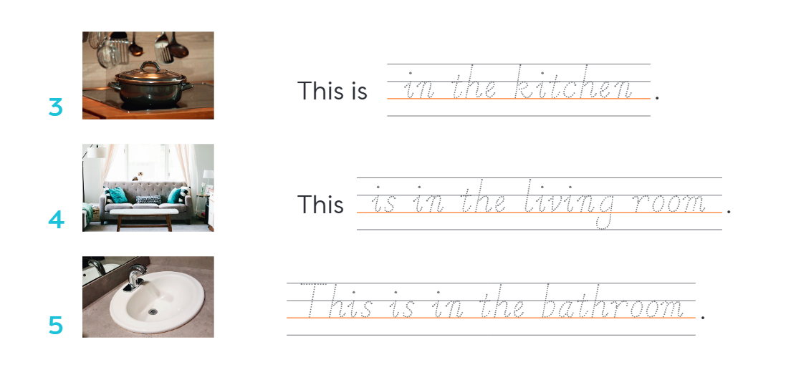

Choose to do（选做）

一．Think about a room in your home and draw a picture of it. Then share it with a friends.

