晋江市伟冠双语实验学校

三年级U5 We’re family 校本作业

Must to do（必做）

一．根据图片补全单词

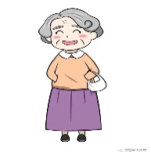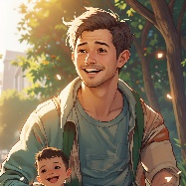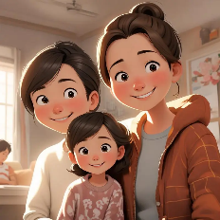

1. f__mily 2.d___d 3. m___ther 4.c___p 5.gr__ndmother

二、选择填空。

( ) 6. This ___________ my family .

A. is B. am C. are

( ) 7. I have ___________ big family.

A.a B. an C. /

( ) 8. This girl is my ___________ .

A. brother B. dad C. sister

( ) 9. ---________ is that ?

---That is my friend .

A. Who B. How many C. What

( ) 10.We are a ___________ family!

A. colour B. happy C. number

**三** 、交际运用，在右栏中找出左栏中问句的答语，并将序号填到括号中

( ) 11.Is she your sister ? A. He is my father .

( ) 12. This is my family . B. Yes , she is .

( ) 13. Who’s he ? C.Wow ,You have a big family !

( ) 14. Let’s take a photo together ! D. Four pencils .

( ) 15. How many pencils ? E. OK.

Choose to do（选做）

一．阅读短文,根据短文内容判断下列句子正(T)误(F)。

We are a big family. My mum can make Chinese knots. She makes eight Chinese knots.My dad has two black umbrellas. My sister has three green balloons. My grandma has two yellow dogs. My grandpa has three blue caps. My brother has twelve small boxes. I have four black pencils.

( ) 1.My dad can make Chinese knots

( ) 2.My dad has two black umbrellas.

( ) 3.My sister has three red balloons

( ) 4.My grandma has two yellow dogs.

( ) 5.My brother has twelve small boxes.