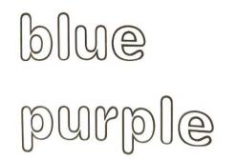

晋江市伟冠双语实验学校

三年级 U3 It’s a colourful world 校本作业

Must to do（必做）

**1.Read and colour.** （读单词，给单词涂上与其意思相符的颜色。）

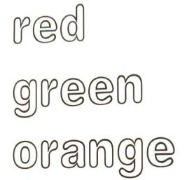

**2. Read and choose.**（根据图片提示，选择正确回答）

|  |  |  |  |  |  |  |  |  |  |  |
| --- | --- | --- | --- | --- | --- | --- | --- | --- | --- | --- |
| |  |  | | --- | --- | | ( )1. What colour is it? | A. It's yellow. | | ( )2. What colour is it? | B. It's purple. | | ( )3. What colour is E? | C.It's colourful. | | ( )4. What colour is the book? | D. It's blue. | | ( )5. What colour is it? | E. It's pink. | |

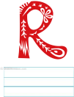

|  |  |  |
| --- | --- | --- |
| yellow+blue= | |  |
| red+blue= |  | |

**3. Look and write.** （把相应字母的颜色写在四线三格上，注意书写规范哦！）

|  |
| --- |
| black  purple  orange  green  red  blue |

**4.Read and write.**

|  |  |  |
| --- | --- | --- |
| yellow+red= |  | |
| red+yellow+blue= | |  |

Choose to do（选做）

**1.Read and choose.** （阅读短文,选择正确的答案。）

Hi, everyone! Let me paint my picture today. This is fun! The schoolbag is yellow. The pencil case is red, The book is blue. The ruler is orange. The eraser is purple. The pencil is green.

Oh,no! I don't have(没有) green.

( )1. What colour is the pencil case?

A. It's yellow B. It's red C. It's blue.

( )2.The is purple.

A. ruler B.eraser C.pencil

( )3. make(使成为)green.

A.  B.  C. 