晋江市伟冠双语实验学校

三年级U2 My school things校本作业

Must to do（必做）

一．Look and write.

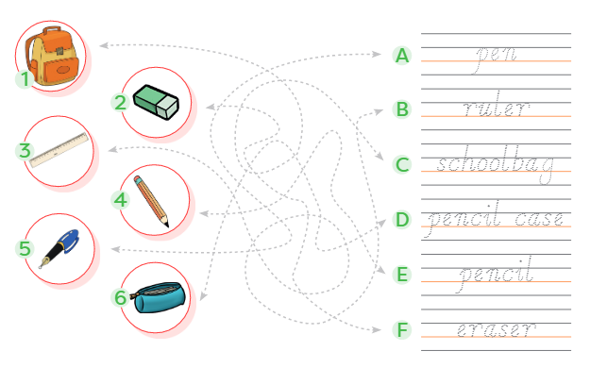

一．Look and read. Then order.

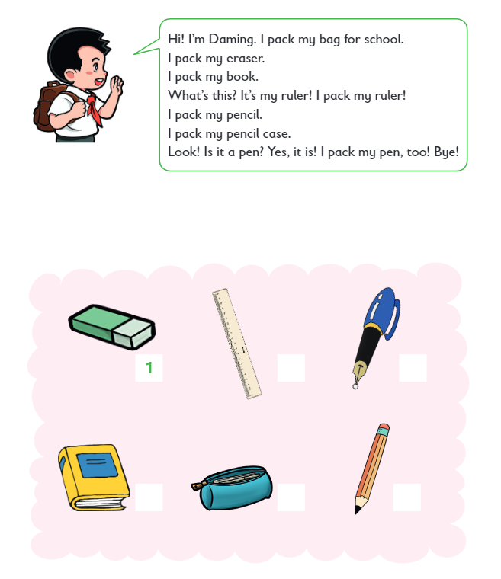

Choose to do（选做）

一．Look and guess, Then join the dots and circle the answers.

